A Venn Diagram of Agile worksheet
Use this worksheet to self-assess how evenly balanced your work is across the three imperatives of the Venn Diagram of Agile.
Assess the work you’re doing in relation to the product or service you provide to your customers, where does it fit on the Venn diagram. Is there too much focus on one or two of the three imperatives? Or are you close enough to the centre and only small adjustments are necessary?
Thinking about each of the three imperatives, distribute 10 points across them to show how much of your focus goes to each one. For example, if most of your focus is on quality with a roughly even split across the other two, you might give ‘Doing the thing right’ 8 points and the others 1 point each.
 | Doing the right thing | Doing the thing right | Short learning cycles
Points
Draw a dot where your efforts are directed in the product or service you deliver for each of the three imperatives, then join the dots to form a triangle and position your final dot in the middle of that triangle.
In the example above you would have something like this:
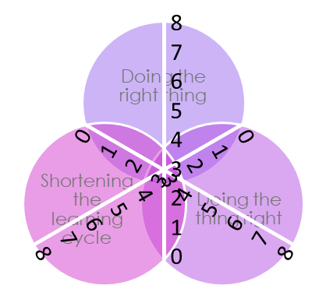
Step 1: Draw a dot where your focus is for each of the three imperatives.
Step 2: Join the dots to form a triangle and place the final dot in the centre.

Now draw your dots, form your triangle and place your focal point for the 3 imperatives.
Don’t feel discouraged if your dot falls somewhere outside the centre of the diagram, this is quite likely the first time you’ve thought about your work this way.
Be grateful that you now have visibility of a possible imbalance and a way to assess it any time you want to make the balance of the three imperatives visible.
Having that visibility is enormously valuable, because now you can choose to do something about it.
What is one thing you could do to bring the focus closer to the centre?
Current focus | One thing I could do differently

